Sudeepto Roy

1546008

SNOOP MASTER

We got a file with no extension.

However, the name gave us a hint to give pcap as an extension and open the file in WireShark.

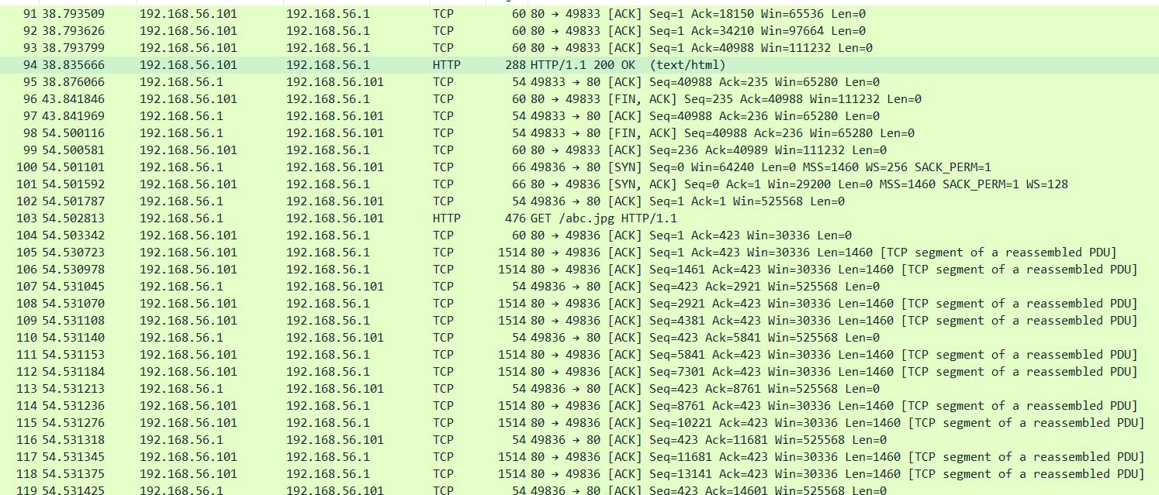

In some HTTP requests, we say an image being passed. So we exported objects from the HTTP requests and downloaded the image.

Opening the image we found our flag.

